Personnel responsible:
Designated Employees involved with Rail Road Spotting

Safety equipment:
- N/A

Procedure
- Material Handler is to notify Office spotting / releasing needs before 15:30 each day
- Rail Cars are to be released and spotted on the web site before 17:00

- Open Raw Material Log  - N:\EngineerOps\RXR&RawMaterial\Raw Material  - Note which cars are spotted and need to be released – enter release date of car(s)  - And chose the next chronological car to be spotted | 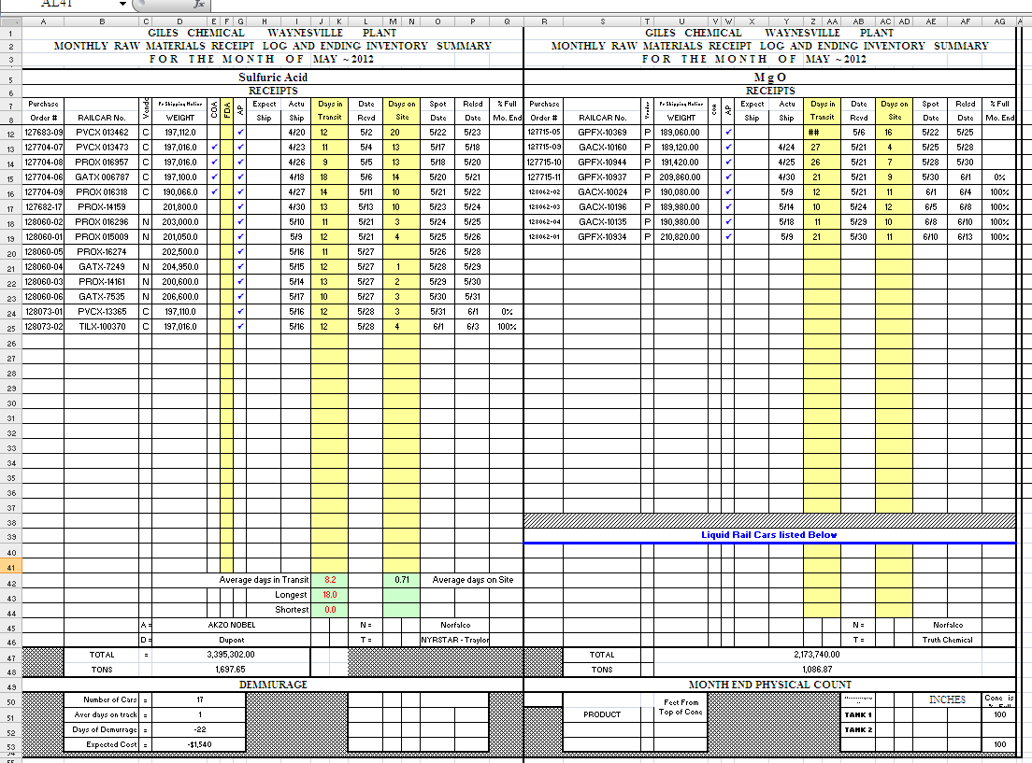
- Open NS website  - https://www2.nscorp.com/accessNS/  - UserID – psk48  - Password – jason963  - Password changes once per quarter….  - If you are prompted to change password – note the password change and email to all effected personnel | 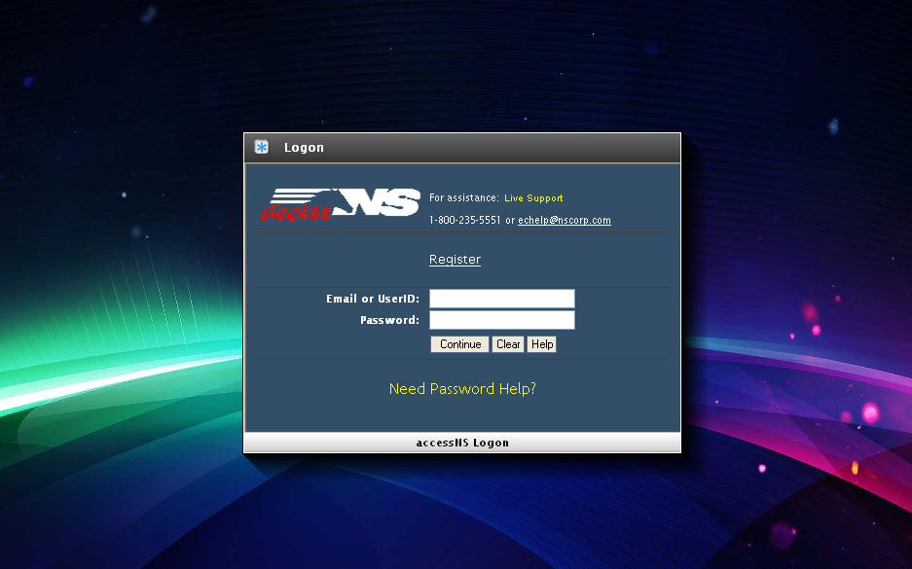
- Click on “On Site Inventory” | 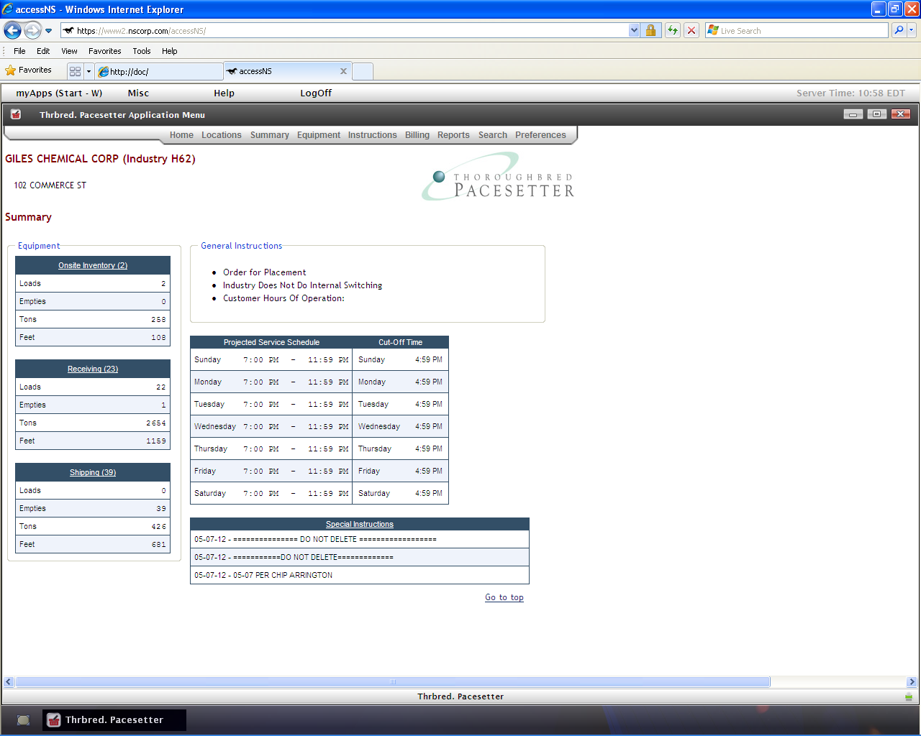
- Chose the rail car(s) to be released by checking the box to the left of car  - Click on “Release Switch”  - When releasing acid cars, you will be prompted to acknowledge it last contained hazardous material –  - Click OK  - Pull down menu will appear – choose “Release Empty”  - Click “Save”  - Check for it to say “release empty” under the Request heading | 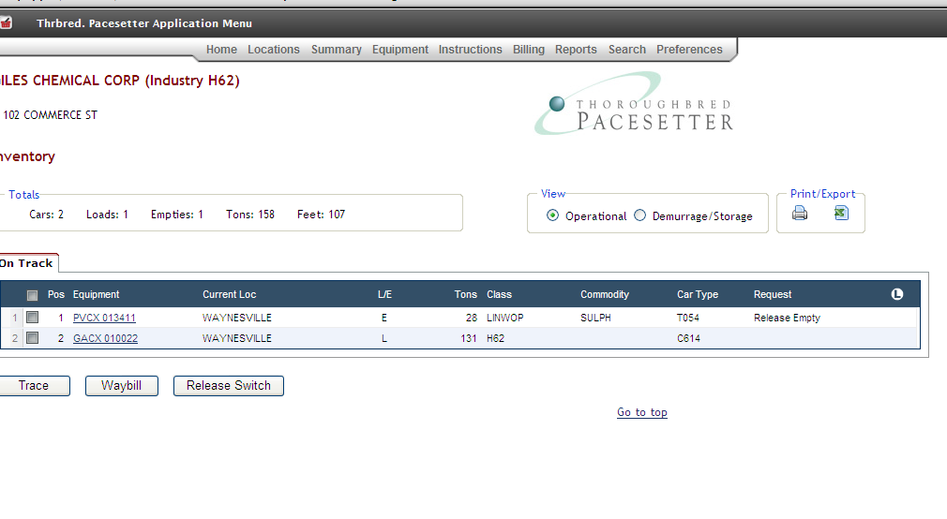
- Chose “Home” on the top menu to go back to the home screen
- Then choose “Receiving”
- Choose the car(s) to be spotted by checking the box to the left of the car  - Calendar screen will pop up – choose the spot date  - Click save  - Check the column labeled “Request” – the word “order” should be beside requested car | 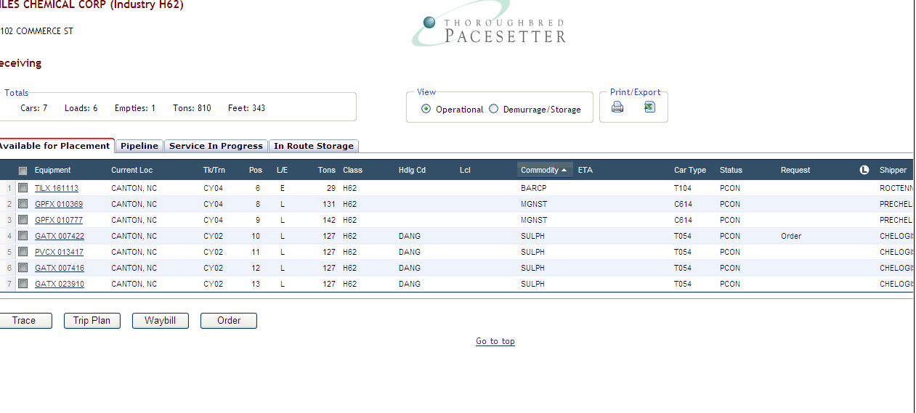
- Log Off

TRAINING DOCUMENTATION

 | EMPLOYEE | TITLE | SIGNATURE | DATE
1
2
3
4
5
6
7
8
9
10
11
12
13
14
15
16
17
18

Revision  Number | Revision  Date | Revision  Author | Revision Description
00 | 10/30/07 | JB | -New Document
01 | 10/10/11 | SL | - Updated whole procedure

